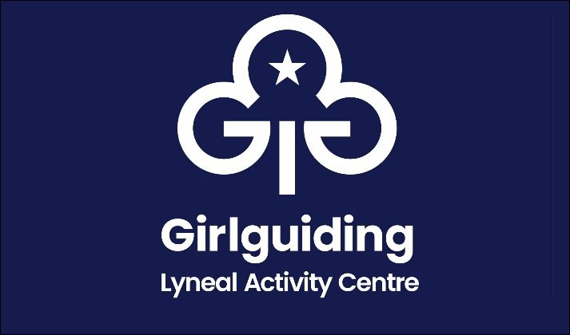
Balance Payment Form

Name of Group
Name of person in charge
Address
Phone number
Email
Date From |  | Arrival time
Date To |  | Departure time

Numbers Attending |  | At £8.00 per night (Guiding & Scouting)  At £10 per night (other) | £
 |  | Less Deposit Paid | - £50.00
 |  | Total To Pay | £

Please Tick
I confirm I have enclosed the balance payment
Cheque made payable to The Guide Association Shropshire
I confirm that I have made a bank transfer for the balance payment
The Guide Association Shropshire sort code 30 18 55 account 00724365
Please use your group name as your payment reference

Signed
Date

This form to be completed and returned to:
Email: lyneal@girlguidingshropshire.org.uk
Mrs Mary Howard, 38 Wem Road, Shawbury, Shrewsbury SY4 4NW 01939 250741

