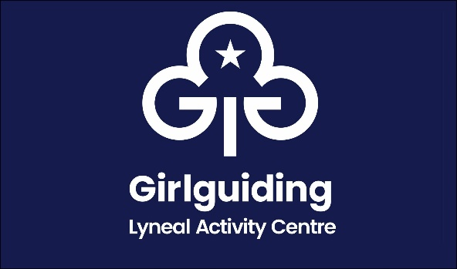

Lyneal Activity Centre Visitor Checklist

|  |  |  |  |
| --- | --- | --- | --- |
| **Group Name** |  | **Date of Visit** |  |
|  | | | |
| **Items to check** | | **On arrival** | **On Exit** |
| **Fire drill** completed | |  |  |
| **Bedrooms** vacuumed, beds left tidy, no personal items remain, windows closed | |  |  |
| **Toilets & sink area** all cleaned thoroughly and floors mopped | |  |  |
| **Wet room** cleaned thoroughly and floors mopped | |  |  |
| **Showers** are all cleaned thoroughly and floors mopped | |  |  |
| **Main hall** vacuumed, windows checked and locked | |  |  |
| **Kitchen** wipe out fridge, microwave, hob and oven, vacuum and mop the floors | |  |  |
| **Bins** are all emptied, please take with you | |  |  |
| **Thermostat** in cloak area returned to 8c | |  |  |
| **Hot water pump** turned off | |  |  |
| **Noticeboards** cleared | |  |  |
| **Entrance hall** swept, shelves left tidy | |  |  |
| **Outbuildings** are left tidy and locked | |  |  |
| Please notify us of any breakages / damages | |  | |
| **Photograph form and forward to** lyneal@girlguidingshropshire.org.uk | |  |  |
| **Signed** | |  |  |