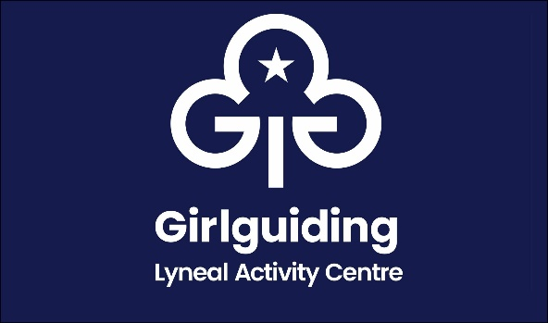
Lyneal Activity Centre Visitor Checklist
Group Name |  |  | Date
Items to check |  | On arrival | On Exit | Committee Member
Fire drill completed
Bedrooms vacuumed, sheets and pillows straightened, no personal items remain, windows closed
Toilets, sinks & showers are all cleaned thoroughly and floors mopped.
Main hall is swept & ‘dusted’. Any ‘spills’ should be ‘dry mopped’ using a damp, (only water) mop then ‘dusted’ using orange duster
Kitchen wipe out fridge, microwave, hob and oven, mop the floors
All bins emptied, please take with you
Thermostat in cloak area returned to 8c & Hot water pump turned off
DO NOT TOUCH ANY SWITCHES INSIDE THE BOILER ROOM PLEASE
Noticeboards cleared
Check all windows are securely closed and curtains left open
Check all doors locked. Key returned. Ensure the front gate is padlocked
DVD / TV / WII please ensure cables are left at Lyneal
Please ensure the internet codes card is left in the hub
Please ensure games / equipment / resources are left tidy
Shop sales we would prefer you to ensure cash is removed and send a cheque made payable to The Guide Association Shropshire to  Mrs Mary Howard, 38 Wem Road, Shawbury, Shrewsbury SY4 4NW  However, if this is not possible please note here if the cash is left |  |  |  | Check for Cash
Other comments / notification of breakages etc
Photograph form and forward to lyneal@girlguidingshropshire.org.uk
Signed

