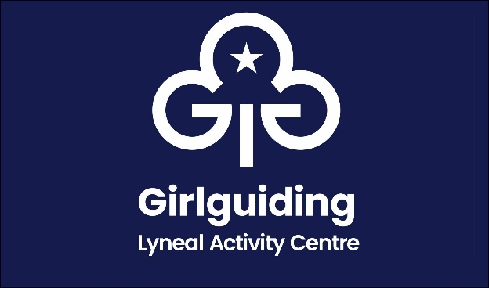
Day Booking Form

Name of Group
Name of person in charge
Address
Phone number
Email
Purpose of visit
Date From |  | Arrival time
Date To |  | Departure time
Estimated total numbers attending

 | Please Tick
I confirm I have read and understand the booking information

I confirm I have enclosed the fee of  Cheque made payable to The Guide Association Shropshire | £30 half day
 | £60 full day
I confirm that I have made a bank transfer for the fee of  The Guide Association Shropshire sort code 30 18 55 account 00724365  Please use your group name as your payment reference | £30 half day
 | £60 full day

Signed
Date

This form to be completed and returned to:
Email: lyneal@girlguidingshropshire.org.uk
Mrs Mary Howard, 38 Wem Road, Shawbury, Shrewsbury SY4 4NW 01939 250741

