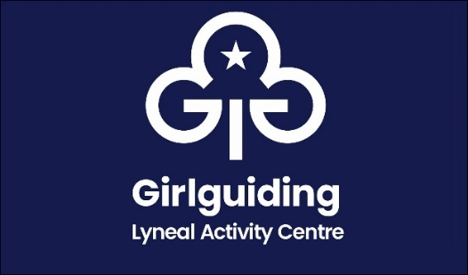
Outdoor Cooking Event
Booking Form

Name of Group / Person

Email

Number attending

Dietary requirements
(e.g. Vegetarian, Lactose free etc)

I confirm that I have made a bank transfer for the fee of £5 per person  The Guide Association Shropshire sort code 30 18 55 account 00724365  Please use “OCE” and your name as your payment reference |  | Amount Paid
I confirm that I have sent a cheque payment for the fee of £5 per person  Cheque payable to: The Guide Association Shropshire  Please post to : Girlguiding Shropshire, 3 & 4 Conwy House, St Georges Business Park, Telford, TF2 7BF  Please write “OCE” on the back of your cheque |  | Amount Paid

Please email the completed form to treasurer@girlguidingshropshire.org.uk
Booking and payment deadline 9th June 2024

Points to Note:
- The event is Saturday 29th June 2024 11am – 2:30pm and we will have alternatives should the weather be too wet
- The cost is £5 per person which includes food
- Open to all Leaders, Unit Helpers, Young Leaders and Rangers
- Please arrange permission forms for under 18 year olds
- Leaders are welcome to bring their own children, please include in the payment numbers

