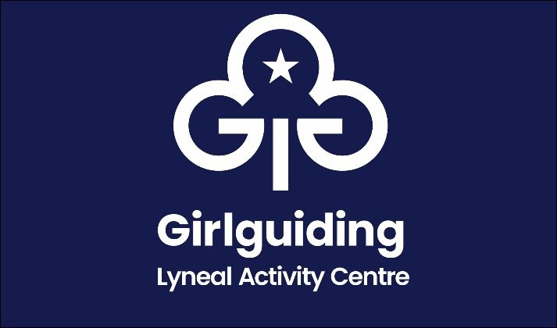
Lyneal Activity Centre
Risk Assessment
This risk assessment has been provided as a guide for what we think are the main risks at the property. Users should carry out their own risk assessments and confirm L/M/H ratings
Hazards | Who or what is at risk of being affected and how? | What are you already doing? | Likelihood of occurring  (L/M/H) | Severity of risk  (L/M/H) | Are further controls necessary?
Car Parking on the playground | Playground accidents  Surface uneven  Lighting at night  Emergency vehicles not being able to access property  Extreme weather conditions | Cars not encouraged when children are in residence  Car park surface is maintained to minimise slip and trip risks  Not well lit at night. Users asked to bring a torch to access padlock codes. External lights can then be put on to aid general access  Large gate allows access for emergency vehicles  Paths, steps and any ramps to and from the hall properly maintained to minimise slip and trip risks |  |  | Cars may be parked onsite but not moved while others are outside  Rock Salt is available for icy conditions
Hirers and volunteers | Accidents because of failure to operate safely | All hirers receive instruction of how to operate within the building and are expected to carry out their own risk assessment for the activities they plan to carry out
Movement around the Building | Slips and trips  Poor Lighting leading to accidents | Matting at the entrances minimises the risk of rainwater being transferred to the hall.  Corridors are clear of any clutter and there are no trailing wires or cables.  All permanent fixtures are in good condition and well secured.  Flooring is well maintained and all carpets are well fitted.  Stairs have a handrail.  Internally everywhere is well lit including rooms and corridors and emergency exits.  Emergency lighting regularly checked and updated in 2021/2022 |  |  | Hirers may introduce a ‘one way system’ and provide their own signage accordingly  Only residential users would need to access upstairs dorms
Electrical equipment and services | Fixed electrical instillations causing injury or fire  Portable electrical equipment causing injury or fire | They correctly installed, modified or repaired, then inspected and tested by an electrician or other suitably qualified person before being put into use.  All portable or movable electrical equipment (e.g. toaster, vacuum cleaner etc.): are visually checked and PAT tested and any damaged electrical equipment is taken out of service and replaced.  We recommend no electrical devices are used in the upstairs bedrooms |  |  | Full electrical checks and updates in December 2020  Additional sockets fitted in kitchen.
Legionnaires’ disease | Showers spreading disease | Shower heads cleaned regularly, descaled and changed  Taps run when the building is empty.  Record kept of checks carried out.
Gas equipment and services | Fixed gas appliances causing injury or fire  LPG (liquefied petroleum gas) causing injury or fire | Checked periodically and any remedial action carried out by a Gas Safe registered engineer.  Carbon Monoxide alarm is fitted in the hall and boiler room.  There is an externally sited LPG installation with a storage vessel.  The area around the vessel is kept clear. The pipes carrying the LPG to the hall are checked to ensure that they are in good condition.
Covid-19 | Covid-19 transmission of virus during events or activities | Current government advice should be followed along with that of any other body the hirer may be affiliated with  All hirers to produce for examination a ‘suitable and sufficient’ risk assessment that minimises the risks of COVID-19
Use of equipment provided | Pyrography: Minor Burns  Whittling: Cuts  Outdoor Cooking: Burns | Demonstration of irons provided by leaders.  Sink and cold water nearby for first aid  Ensure all users understand safe use of sharp tools  Ensure first aid kit handy for cuts  Ensure all users understand safe use  Ensure bucket of cold water nearby
Fire | Fire causing injury | The whole site is no smoking  A fire risk assessment been completed and adequate fire safety measures are in place  An evacuation plan has been implemented and tested  A maximum of 24 over night guests are permitted  The fire doors around the building should remain closed especially at night  The fire alarm tested regularly  Fire drills are carried out by users  Regular checks are made to ensure escape routes and fire exit doors are unobstructed and are adequate and effective for the number of people using the hall (including those who are disabled or vulnerable)  All combustible substances or waste are stored safely  Fire extinguishers are in place and are checked annually  The fire meeting point is the playground |  |  | Users should plan how they would evacuate especially at night  Users should ensure fire doors are closed  Fire drills need to be carried out by users  Fire escape route plans are in red frames throughout the building. Users should ensure they are aware of their route

