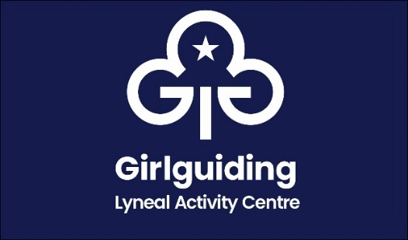
Lyneal Social Event Information
14th June 2025 with an optional overnight stay

Lyneal Activity Centre invites you to attend an informal non-uniform Leaders social event with a rough itinerary as below

Arrive Saturday 14th June 12 noon with an Afternoon Tea style lunch being served at 1pm

In the afternoon there will be a chance to look around Lyneal at the activities and equipment at the centre and try your hand at some crafts.

A Division Outdoor Adviser will also be available should you wish to chat about taking your Going Away with licence.

You can also look through the visitors' books to see what events and themes have been held in the past. The Lyneal Shop will also be open for purchases.

From 5pm we will be trying out different outdoor cooking equipment to prepare our evening meal. This will be hands on and there will be lots of different things to graze and try.

This will be followed by a campfire with songs and the day event is expected to finish at 8pm

The cost for this is £12 per person

There is the add on option to stay overnight. There are 16 places on a first come first served basis, but please note some of them are top bunk beds.

Saturday evening activities include bat detecting, Lyneal Prize bingo will start at 9pm and general socialising! Please feel free to bring your own alcoholic beverages 😊

Sunday there are no activities planned but we will start with a full cooked breakfast at 8:30am. We suggest an optional walk to Colemere. We would appreciate some help with the clearing up if you are able to lend a hand from 10:30am and we expect to leave around 12 noon

The cost is an additional £6 per person (making £18 in total)

We have waived our overnight fee of £8.50 per person as you are the guest of Lyneal

You will need to bring a sleeping bag/duvet, bottom sheet and pillowcase as well as your own personal kit if you are staying overnight

Lyneal Social Event
Booking Form

Name

Email

Dietary requirements
(e.g. Vegetarian, Lactose free etc)

Any other requirements or adjustments we need to know about?
e.g. health or mobility

I am attending for the | Day at £12 |  |  | Weekend at £18
I am paying by | Bank Transfer |  |  | Cheque
Payment Details

The Guide Association Shropshire

Sort code 30 18 55 account 00724365

Please post cheques to : Girlguiding Shropshire, 3 & 4 Conwy House, St Georges Business Park, Telford, TF2 7BF

Please email the completed form to treasurer@girlguidingshropshire.org.uk
Booking and payment deadline 17th May 2025

